

**Name of the Assignment : 1.**women's role in society and culture of Bangladesh

2. IT sector of Bangladesh

**Course Tittle :** Bangladesh Studies

**Course Code :** ICT-1209

**Submitted To Submitted By**

[Ananna Zulfiqar Showly](https://juniv.edu/teachers/ananna.showly) MD Shakil Hossain

Lecturer, Roll - 2023

Department of Archaeology 1st year 2nd Semester

JU IIT-JU

women's role in society and culture of Bangladesh

Introduction:

Women, in custom and practice, remained subordinate to men in almost all aspects of their lives; greater autonomy was the privilege of the rich or the necessity of the very poor. Most women's lives remained centered on their traditional roles, and they had limited access to markets, productive services, education, health care, and local government. This lack of opportunities contributed to high fertility patterns, which diminished family well-being, contributed to the malnourishment and generally poor health of children, and frustrated educational and other national development goals. In fact, acute poverty at the margin appeared to be hitting hardest at women. As long as women's access to health care, education, and training remained limited, prospects for improved productivity among the female population remained poor.

About 82 percent of women lived in rural areas in the late 1980s. The majority of rural women, perhaps 70 percent, were in small cultivator, tenant, and landless households; many worked as laborers part time or seasonally, usually in post-harvest activities, and received payment in kind or in meager cash wages. Another 20 percent, mostly in poor landless households, depended on casual labor, gleaning, begging, and other irregular sources of income; typically, their income was essential to household survival. The remaining 10 percent of women were in households mainly in the professional, trading, or large-scale landowning categories, and they usually did not work outside the home.

The economic contribution of women was substantial but largely unacknowledged. Women in rural areas were responsible for most of the post-harvest work, which was done in the *chula*, and for keeping livestock, poultry, and small gardens. Women in cities relied on domestic and traditional jobs, but in the 1980s they increasingly worked in manufacturing jobs, especially in the readymade garment industry. Those with more education worked in government, health care, and teaching, but their numbers remained very small. Continuing high rates of population growth and the declining availability of work based in the *chula* meant that more women sought employment outside the home. Accordingly, the female labor force participation rate doubled between 1974 and 1984, when it reached nearly 8 percent. Female wage rates in the 1980s were low, typically ranging between 20 and 30 percent of male wage rates.

Women’s ability to enjoy civil, political, economic, social and cultural rights is interlinked with the issue of discrimination. Discrimination based on gender ideology and patriarchy was not initially considered as part of the human rights agenda. Excluding sex discrimination and violence against women from the human rights agenda also results from a failure to see the oppression of women as political.Female subordination runs so deep that it is still viewed as inevitable or natural rather than as a politically constructed reality maintained by patriarchal interests, ideology, and institutions.

*Literacy*—Women are much less likely than men to be literate. In South Asia, female literacy rates are only around 50% those of males ,in Nepal 35% . Women make up two-thirds of the world’s illiterates.

*Higher education*—Women in developing countries lag far behind men. Even in industrial countries, women are very poorly represented in scientific and technical study .

*Employment*—In developing countries women have many fewer job opportunities, the employment participation rates of women are on average only 50% those of men (in South Asia 29%) .Wage discrimination is also a feature of industrial countries. Women who are not in paid employment are, of course, far from idle.Indeed, they tend to work much longer hours than men .

*Health*—Women tend on average to live longer than men.But in some Asian country, the discrimination against women—through neglect of their health or nutrition—is such that they have a shorter life expectancy . . .

*National statistics*—Women are often invisible in statistics. If women’s unpaid housework were counted as productive output in national income accounts, global output would increase by 20-30%

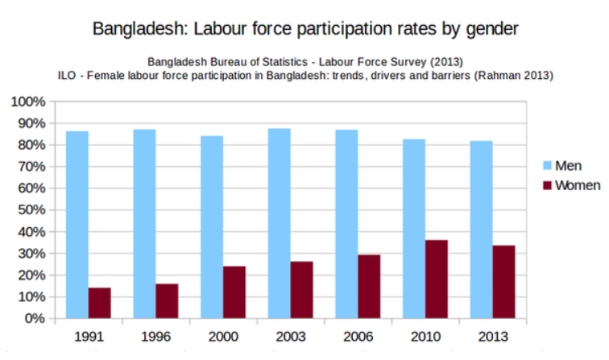

The status of women in Bangladesh has been subject to many important changes over the past few centuries. The [Bangladeshi](https://en.wikipedia.org/wiki/Bangladeshi) women have made significant progress since the country gained its independence in 1971. The past four decades have seen increased political empowerment for women, better job prospects, increased opportunities of education and the adoption of new laws to protect their rights though Bangladesh's policies regarding women's rights is influenced by [patriarchal values](https://en.wikipedia.org/wiki/Patriarchy). As of 2018, the [Prime Minister of Bangladesh](https://en.wikipedia.org/wiki/Prime_Minister_of_Bangladesh), the [Speaker of Parliament](https://en.wikipedia.org/wiki/Speaker_of_Jatiyo_Shangshad), the [Leader of the Opposition](https://en.wikipedia.org/wiki/Leader_of_the_Opposition_(Bangladesh)) were women. Bangladesh has also not elected a male as Prime Minister [since 1988](https://en.wikipedia.org/wiki/1988_Bangladeshi_general_election).

## Politics: Women politician in Bangladesh:

## 1.Shirin Sharmin Chaudhury is the current and the first woman [Speaker](https://en.wikipedia.org/wiki/Speaker_(politics)) of the [Jatiya Sangsad](https://en.wikipedia.org/wiki/Jatiya_Sangsad) since April 2013.

## 2. Matia Chowdhury is a Bangladeshi politician, and the incumbent Member of Parliament from [Sherpur-2](https://en.wikipedia.org/wiki/Sherpur-2). She is a presidium member of [Bangladesh Awami League](https://en.wikipedia.org/wiki/Bangladesh_Awami_League), and was the Minister of Agriculture under the prime ministership of [Sheikh Hasina](https://en.wikipedia.org/wiki/Sheikh_Hasina).

3. **Dipu Moni** is a [Bangladeshi](https://en.wikipedia.org/wiki/Bangladesh) politician who is serving [Bangladesh Government](https://en.wikipedia.org/wiki/Government_of_Bangladesh) as the [Minister of Education of Bangladesh](https://en.wikipedia.org/wiki/Ministry_of_Education_(Bangladesh)) since January 2019. She served Bangladesh as [Foreign Minister of Bangladesh](https://en.wikipedia.org/wiki/Minister_of_Foreign_Affairs_(Bangladesh)) from 2009 to 2013

4. **Sheikh Hasina** is a Bangladeshi politician serving as the 10th [Prime Minister of Bangladesh](https://en.wikipedia.org/wiki/Prime_Minister_of_Bangladesh), having held the office since January 2009. She had previously served as Prime Minister from 1996 to 2001. She is the longest-serving prime minister in the history of Bangladesh.

5. **Ivy Rahman** was a Bangladeshi politician. She was the Women's Affairs secretary of [Awami League](https://en.wikipedia.org/wiki/Awami_League).

6. **Khaleda Zia** is a [Bangladeshi](https://en.wikipedia.org/wiki/Bangladesh) politician who served as the [Prime Minister of Bangladesh](https://en.wikipedia.org/wiki/Prime_Minister_of_Bangladesh) from 1991 to 1996, and again from 2001 to 2006. She was the first woman in the country's history and second in the [Muslim majority countries](https://en.wikipedia.org/wiki/List_of_Muslim_majority_countries) to head a democratic government as prime minister.

## SPORTS:

## 1. Name of some Bangladeshi women cricketers:

* [Rumana Ahmed](https://en.wikipedia.org/wiki/Rumana_Ahmed)
* [Ayesha Akhter](https://en.wikipedia.org/wiki/Ayesha_Akhter)
* [Sharmin Akhter](https://en.wikipedia.org/wiki/Sharmin_Akhter)
* [Shohely Akhter](https://en.wikipedia.org/wiki/Shohely_Akhter)
* [Tazia Akhter](https://en.wikipedia.org/wiki/Tazia_Akhter)
* [Nahida Akter](https://en.wikipedia.org/wiki/Nahida_Akter)
* [Jahanara Alam](https://en.wikipedia.org/wiki/Jahanara_Alam)
* [Suraiya Azmin](https://en.wikipedia.org/wiki/Suraiya_Azmin)

2. Name of some Bangladeshi women footballers:

* [Akhi Khatun](https://en.wikipedia.org/wiki/Akhi_Khatun)
* [Sabina Khatun](https://en.wikipedia.org/wiki/Sabina_Khatun)
* [Tohura Khatun](https://en.wikipedia.org/wiki/Tohura_Khatun)
* [Shamsunnahar](https://en.wikipedia.org/wiki/Shamsunnahar_(footballer,_born_2003))
* [Mosammat Sirat Jahan Shopna](https://en.wikipedia.org/wiki/Mosammat_Sirat_Jahan_Shopna)

## 3. Bangladeshi female swimmers

* Doli Akhter
* Sonia Aktar
* Mahfuza Khatun

**Literature:** List of notable women writers who were born in Bangladesh:

1.[Roquia Sakhawat Hussain](https://en.wikipedia.org/wiki/Roquia_Sakhawat_Hussain) (1880–1932), essayist, short story writer, novelist, poet, feminist, author of [Sultana's Dream](https://en.wikipedia.org/wiki/Sultana%27s_Dream).

2**.**[Jahanara Imam](https://en.wikipedia.org/wiki/Jahanara_Imam) (1929–1994), non-fiction writer, diarist, political activist.

3. Sufia Kamal(1911–1999), poet, feminist.

4. [Husne Ara Shahed](https://en.wikipedia.org/wiki/Husne_Ara_Shahed)**,** contemporary novelist, non-fiction writer, educator.

5. [Iffat Ara](https://en.wikipedia.org/wiki/Iffat_Ara) (born 1939), novelist, short story writer, essayist, magazine editor, educator, women's rights activist.

IT sector of Bangladesh

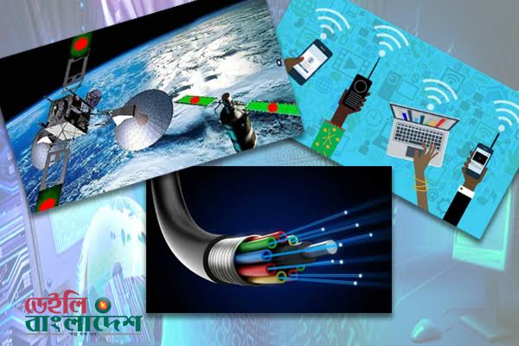

Introduction:

Information Technology (IT) gives fast, easy access to information which is essential for the development of a nation. Large IT companies are opening around the world, and nations are building up IT platforms, developing and promoting their IT industries. Asian countries are also becoming stakeholders in this boom by creating conducive environments, drawing global IT companies to invest there. Existing giants like Microsoft, Apple, Samsung, etc. are making massive investments in Asian countries to utilise the cost advantage. Bangladesh, with its huge under-utilised manpower, can also benefit from these initiatives, provided an established foreign investment platform with a nationwide IT infrastructure and skilled labour force is created.

Bangladesh's IT Industry:

Considerable achievements in the IT sector have already been made over several years towards building a 'Digital Bangladesh' and more initiatives are coming. However, to fully capitalise on the opportunities offered by the worldwide IT expansion, Bangladesh should thrust heavily towards further developing the IT sector to draw the attention of foreign investors competing with other technologically advanced/well-invested Asian countries. At the same time, we should encourage our entrepreneurs to launch IT companies here. Both these efforts would create hundreds of thousands of IT jobs and, consequently, help Bangladesh become a middle-income country by 2021.

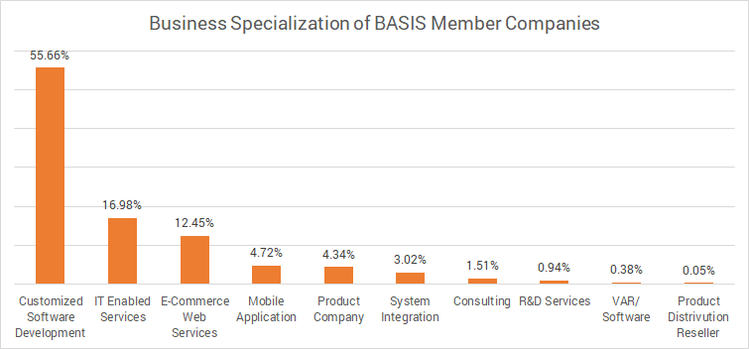

With an age less than 50 years and more than 43% of its population under the age of 25, Bangladesh is a young country in more ways than one, a major competitive advantage considering that more than half of its population of 160 million are in prime working ages (15-54) . Although the RMG sector remains dominant in the nation’s contribution to GDP and workforce, ICT is the new underdog that may be soon to catch up due to large foreign investments, government incentives, and favorable policies for the industry. Unlike other industries however, ICT has the potential to directly impact and transform other markets given the overreaching effects of automation, AI, big data, and advanced analytics is having in other countries throughout the world. The question for Bangladesh, however, remains not whether the country will be able to achieve its goal in 2021 of $5bn in exports, but whether this industry may in the future become the nation’s 3rd engine.

The government can accelerate investments in English and IT education starting at primary schools to scale up this industry. Enabling conditions such as, improving transportation, communication, physical infrastructure of major IT hubs, installing work ethics, transparency, accountability laws, strengthening regulatory roles, and ensuring homeland security can turn Bangladesh into a popular investment destination.A government promoted private-public partnership foundation can be established to promote investment in IT and aid entrepreneurs. Institutions already working towards developing the IT sector (for example, BASIS) can become partners in this effort and senior representatives from key government agencies (for example, the Computer Council) should be included to advice investors on policies and procedures. Together, they can attract foreign investment in Bangladesh's IT industry. A global network of small overseas IT trade offices can also be established to attract and assist investors in setting up IT companies and service centers in Bangladesh.

The Information Technology industry is such a new sector in Bangladeshi economy. It is an important growth industry. The [Bangladesh Association of Software and Information Services](https://en.wikipedia.org/wiki/Bangladesh_Association_of_Software_and_Information_Services) (BASIS) was established as the national trade body for software and IT service industry. In a study among Asian countries by [Japan International Cooperation Agency](https://en.wikipedia.org/wiki/Japan_International_Cooperation_Agency)(JICA) in 2007–08, Bangladesh was ranked first in software and IT services competitiveness and third in competencies, after India and China. The [World Bank](https://en.wikipedia.org/wiki/World_Bank), in a study conducted in 2008, projected triple digit growth for Bangladesh in IT services and software exports. The [Internet penetration](https://en.wikipedia.org/wiki/Broadband_universal_service) has also grown to 21.27 percent in 2012, up from 3.2 percent three years prior. But still Bangladeshi people are not so qualified to use ICT. So Bangladeshi government is giving much priority in it. If Bangladesh wants to become digital Bangladesh, she (Bangladesh) must make sure of giving ICT education to her childrens and therefore Bangladesh can make the best use of it. From a TV source of Bangladesh, government agreed to give the light of programming knowledge to the childrens from the primary level of their life.

* The Information and Communications Technology (ICT) sector of the country has maintained 57.21 percent export growth on an average over the last nine years since 2009.
* In the fiscal year (FY) 2016-17, Bangladesh ICT sector registered export earnings worth US$0.8 billion from the global market and US$1.54 billion from the domestic market span - thereby making around one percent contribution to the gross domestic product (GDP).
* The ICT sector has created around three hundred thousand job opportunities so far.
* As the Internet usage increases, the government expects the IT sector to add 7.28 percent to GDP growth by 2021.